**ASSIGNMENT-7.3:**

Write a custom key to evaluate the number of people who died and the number of people who survived, along with their genders.

Driver Class:

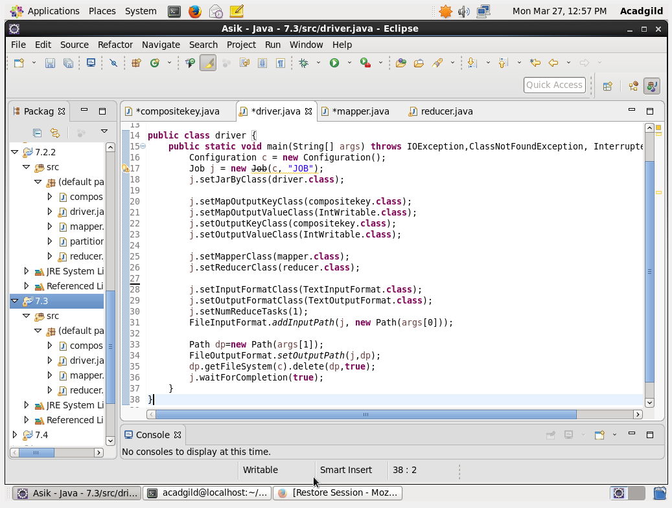

Mapper Class: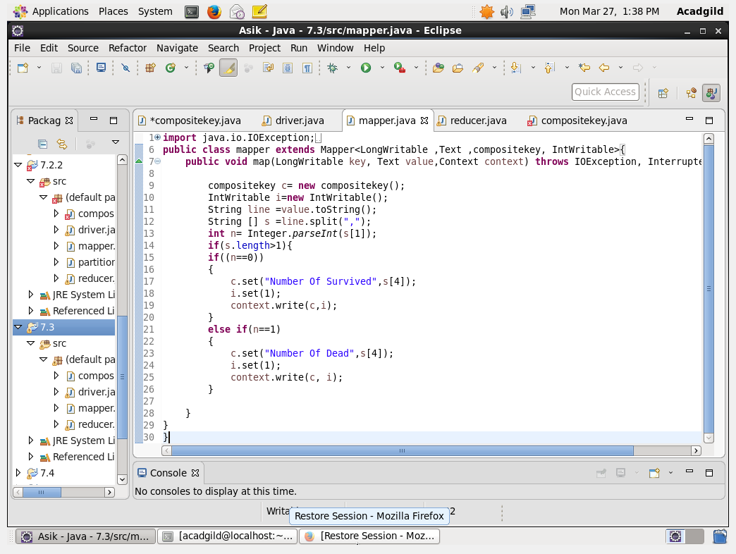

Reducer Class:

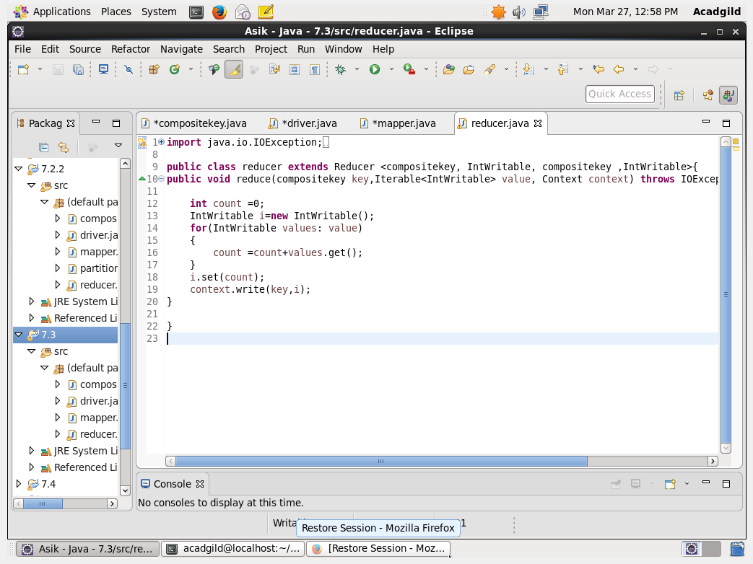

CompositeKey Class:

Step 1: Overriding HashCode returning HashCode of status (dead or survived)

Step 2: Overriding Equals method: Checks the status and gender are equal for every object if equal it will send to the corresponding HashCode location else compare to will be done

Step 3: Overriding CompareTo method: if both the status are equal if its same it will compare the gender and it will be send and framework sorting will be made on it or else if different it will send the status and framework sorting will be made on it

Readfields and Writefields are used for serialization and deserialization

COMPOSITEKEY CLASS Code :

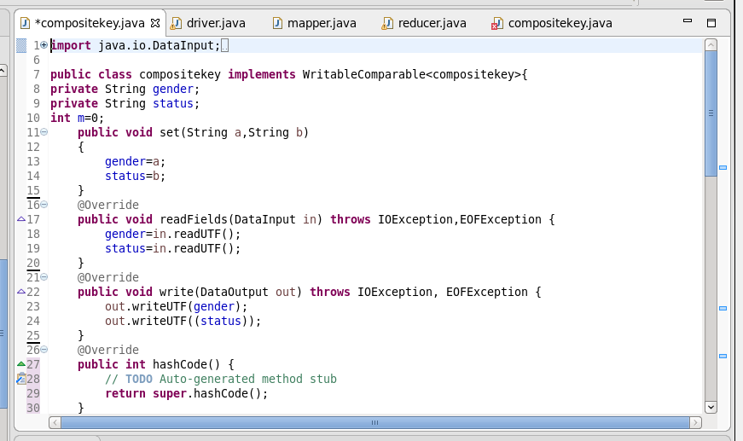

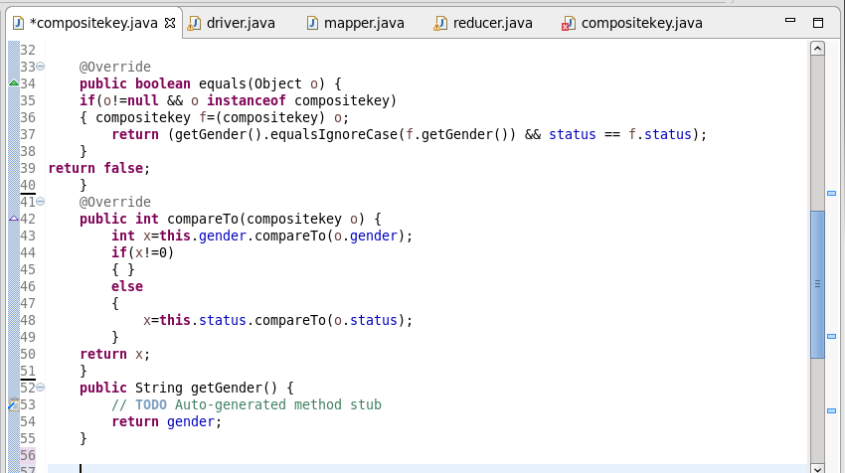

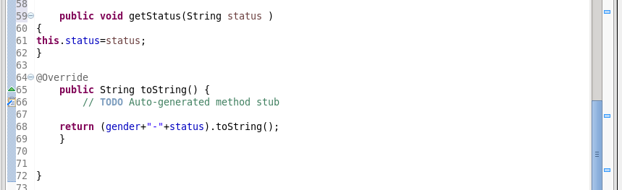

Output:

